Accidental space part 1: algebra and networks
Ricardo Javier Rademacher Mena

Abstract
In part one of five, we examine patterns within the intervallic and accidentals spellings of four heptatonic scales: major, melodic minor, neapolitan major, and harmonic minor. The modes from these scales are recast as forward and inverse modes and an accidental algebra is defined on the space of flat and sharp accidental operators. This algebra describes a quasi-pseudometric space of scale degrees known as accidental space which allows for the creation of accidental networks, which map any mode to any other mode, and modal wheels, unique major and melodic minor networks combined with other scales. The purpose of this paper is to provide an introduction to these concepts; further extensions, interpretations, and applications are discussed in future investigations.

Table of Contents
Introduction 2
Forward and inverse major modes 4
Accidental space and the major A-net 7
The melodic minor A-net 17
The major plus melodic minor A-net: the modal wheel 20
The modal wheel plus neapolitan major: the diatonic wheel 22
The modal wheel plus harmonic minor: the harmonic wheel 24
The almost full A-net: the big wheel. 26
Future investigations 29
References 32

Introduction
Let us imagine for a second that we are learning music for the first time and wish to understand the concept of modes. We would start with the concept of a scale. The modern scale has seven notes (heptatonic) with those seven notes chosen from the chromatic scale, the twelve note equally divided octave from which all modern music is composed. In this paper, we will consider four heptatonic scales: major, melodic minor (a.k.a. the jazz scale), neapolitan major, and harmonic minor. Having introduced notes and scales, next we might introduce scale degrees, which are abstractions of the seven distinct notes always present in a heptatonic scale. To each scale degree, we can also attribute a chord quality. Thus in the major scale, the first scale degree is considered a major and annotated with the capital I or ∆, while in the melodic minor, harmonic minor, and neapolitan major, the first scale degree is considered a minor and annotated with a lowercase i or “m”. Other qualities include half-diminished, annotated as Ø; fully-diminished, annotated as “O”; augmented, annotated as +; dominant (a.k.a. major-minor), left un-annotated or ∆m; and the minor-major quality annotated as m∆.
Having learned about the notes that comprise each mode as well as scale degrees and chord quality, we may wish to learn about intervallic spellings. We would at this time recite the major scale’s familiar mantra of whole – whole – half – whole – whole – whole – half, where each whole refers to a whole-step or tone and each half refers to a half-step or semitone. The modes are then introduced as the seven different spellings that result from permutations of this intervallic spelling. A permutation means moving the first element of the list to the end, taking the second element as the first, and then reading the result as normal. Permuting the first mode of the major scale, ionian, thus leads us to the second mode, dorian, which has the intervallic spelling: whole – half – whole – whole – whole - half – whole. Permuting once on dorian results in the phrygian mode, another permutation results in the lydian mode, and so on until the eighth permutation, which takes you back to ionian.
Having finally defined a mode, the next important thing to learn is how to play them on an instrument. A piano is an excellent first choice since each white and black key in succession constitutes a half-step. Thus twelve keys in succession span the chromatic scale and in the key of C, the ionian mode would consist of your playing only white keys. Then you would be told the dorian mode would consist of your playing a “flat three, flat seven.” This means that instead of playing the third white key, E, you would go down a half-step and play that black key instead, which would be an Eb. Similarly, instead of playing the seventh scale degree, the seventh white key, B, you would once again have to go down a half step and play a Bb instead. Now, if you play those black keys, Eb and Bb, instead of the E and B white keys and keep everything else unchanged, then you are playing in the dorian mode instead of the ionian mode.
In summary, there are four ways to reference a mode: notes, scale degree, intervallic spelling, and accidental spelling (i.e., which black keys are used). In this paper, we will use all four representations to analyze heptatonic scales with an emphasis on the intervallic and accidental spellings. Our aim is to find a straightforward way to navigate the various modes and reveal deeper symmetries within.

Forward and inverse major modes
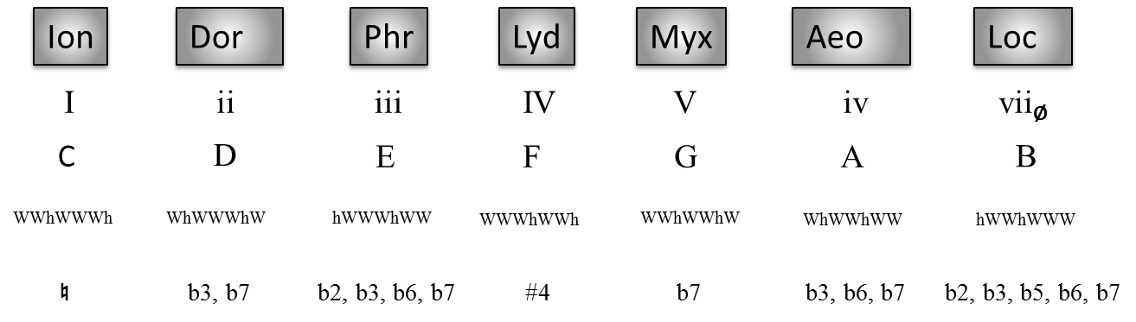
Figure 1: Major modes with scale degree, notes, intervallic spelling, and accidental spelling.
Figure 1 shows the four modal representations discussed in the introduction for the major scale. We start our investigation with a seemingly innocent observation. When looking at the intervallic spelling of the various major modes, we notice that the dorian mode is unique in that it is palindromic. This means that its intervallic spelling reads the same forwards as it does backwards. The importance of this observation lay in group theory (Carter, 2009), where each group has a unique element, the identity, that acts the same on left and right elements; i.e., it reads the same forwards and backwards. This identity would also be known as the origin in vector algebra. If we now proceed to investigate its two neighbors, ionian and phrygian, we notice that if you read the ionian intervallic spelling backwards, it would spell the phrygian intervallic spelling and vice versa. Looking at the remaining set of modes, we identify two other such pairs: myxolydian and aeolian as well as lydian and locrian. Borrowing from the language of group theory, we say that each mode in these mode pairs is the inverse of the other, while dorian is its own inverse. So for example, since phrygian is ionian spelled backwards, we might consider that phrygian is ionian⁻¹, where the exponent labels that mode as an inverse. Of course the reverse is also true; we can also read phrygian forward and then ionian becomes phrygian⁻¹. Figure 2 shows the results of this pairing of inverses and the adoption of following conventions:
- The regular mode, the one whose intervallic spelling we read from low to high, left to right, is the forward mode while the mode which reads the same as the forward mode but from high to low, right to left, is the inverse mode.
- When relevant I fully work through a lot of your feedback so who’s ready for another round? :-), we will label our modes in inverse pairs. Thus using ionian and ionian⁻¹ as labels is valid but ionian and phrygian or ionian⁻¹ and phrygian⁻¹ is not.
- Given the palindromic nature of the dorian mode, we can consider it as either a forward or inverse mode. As all other minor modes are inverses, we adopt the convention of making dorian an inverse as well.
- In diagrams, modes that are major, dominant, or augmented will be in all capital letters while modes that are minor, minor-major, half-, or fully-diminished in all lowercase.
Having identified our forward and inverse modes, let us now re-organize the set of major modes and group them by chord quality. By our choice of dorian being an inverse, the forward modes line up exactly with the major chord quality while the inverse modes line up exactly with the minor chord quality. We can further see that by our grouping, and some shuffling about, we can establish the familiar organization of a circle of fifths, as seen in figure 3, will which relies on the interval of a perfect fifth (P5), shown in figure 4. Let us take an aside and examine the mathematical consequences of combining the concept of forward and inverse modes with a circle of fifth progression.
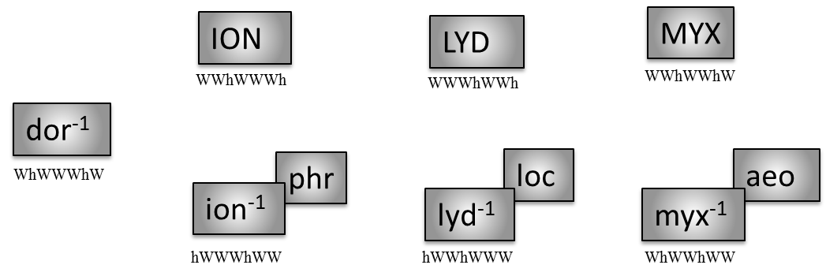
Figure 2: Major modes and their inverses.

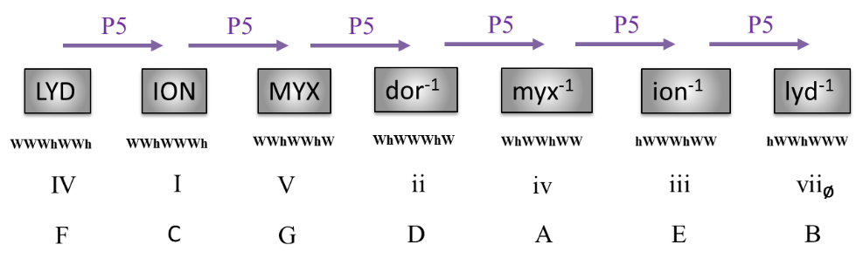
Figure 3: Circle of fifths progression through the major modes.

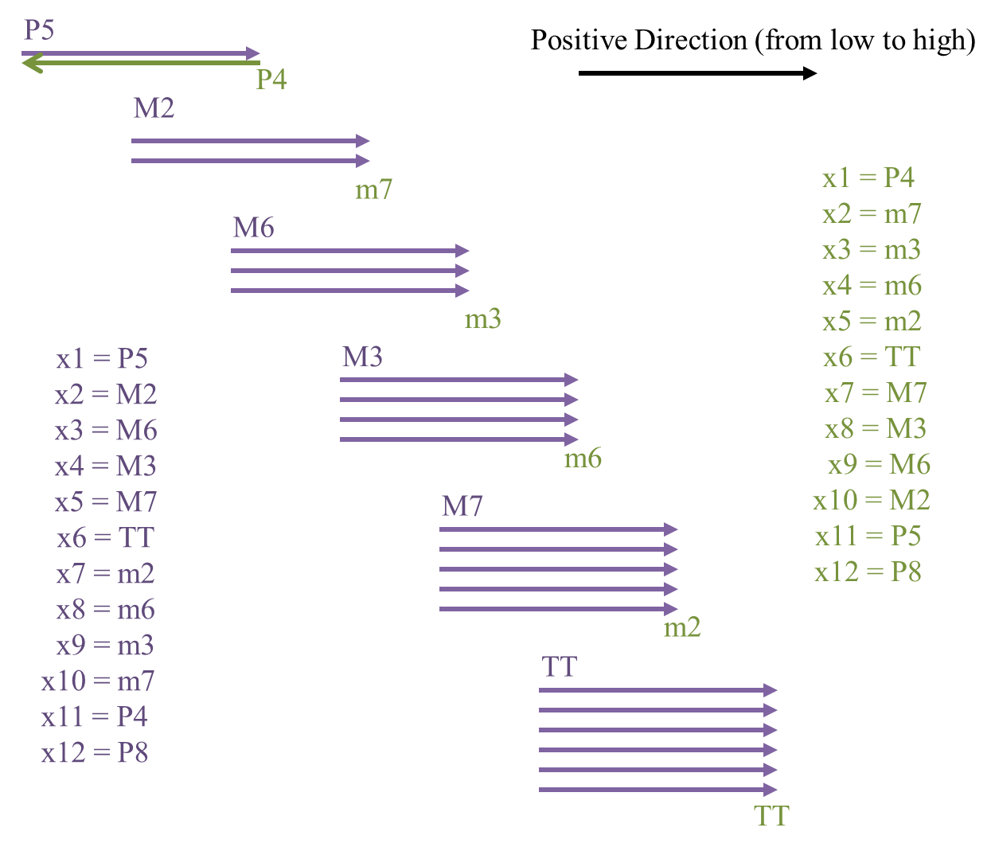
Figure 4: Jumps in fifths and fourths.

Accidental algebra and A-space
Vector | |mode> = |234567>
Inverse Vector | <mode| = |mode⁻¹> = <234567|
Origin | |♮> = <♮| = |♮♮♮♮♮♮> = |1>
Operators | |♮|, |b2|, |#2|, |b3|, |#3|, |b4|, |#4|, ...  |b| = |b><♮| = |♮><#| = |#|⁻¹  |#| = |#><♮| = |♮><b| = |b|⁻¹  |♮| = |#><#| = |b><b| = |♮><♮|
Identity | ♮|b> = |b>  ♮|#> = |#>  ♮|♮> = |♮>
Addition and subtraction | #|♮> = |#>  b|♮> = |b>  b|#> = #|b> = |♮>
Table 1: Accidental algebra vectors and operators in the key of C.
To aid in understanding the modes, we will need to establish a consistent set of rules for referencing and manipulating them. Summarized in table 1, we will call these rules the accidental algebra. The beginning of accidental algebra is the unique identification of each mode by the number of sharps or flats required to reach it from another mode with no sharps or flats; i.e., the origin or natural mode. Thus, we uniquely identify the lydian mode by virtue of having to sharp the fourth degree of the scale relative to ionian while myxolydian is uniquely identified by having to flat the seventh degree. If we identify modes by their scale degrees, |234567>, and then denote whether that scale degree is natural, flat, or sharp, then our ionian, lydian, and myxolydian modes would look like |♮♮♮♮♮♮>, |♮♮#♮♮♮>, and |♮♮♮♮♮b> respectively. This |mode> construct, formally called the ket in bra-ket or Dirac notation (Shankar, 1988), will refer to a mode that is read forwards and will refer to the previously mentioned forward mode while we identify the bra, <234567|, with the previously mentioned inverse mode.
We can define the space of flat and sharp accidentals as a type of metric space called accidental space or A-space, since each mode is a predefined flat or sharp distance away from another. In this paper, each mode represents a particular position within A-space. The natural mode, |♮♮♮♮♮♮> = |♮> =|mode>, will refer to a relative origin of choice while the absolute mode will refer to choosing C ionian as the natural mode, |♮> = |ion> = |0>. We make this distinction because through a change of basis, |♮> ≠ |ion>, we change our origin, natural mode, and accidental spellings but there will always only be one absolute mode |0> for which the keys are all white on the piano. As examples of the naming convention for our bases, when the natural mode is assigned to ionian, we refer to that as the ionian basis; when we switch the origin to locrian, then we would be in the locrian basis; put the origin on lydian to be in the lydian basis, and so on.
The accidentals now take on the role of operators that act on the modes or accidental operators. There are 13 such operators: a flat and a sharp for each scale degree (|b2|, |#2|, |b3|, |#3|, …) and one unique “do nothing” natural operator, |♮|. Applying a flat operator to a mode and thus flattening that scale degree represents a change in position in A-space and correspondingly a change of mode. For example, if we apply the sharp four operator on the origin, #4|♮>, then we can say that we have moved a fourth scale degree up and annotate that by |#4>, which is shorthand for |♮♮#♮♮♮>. However, really all this is saying is that you take the notes in the key of C and play an F# instead of an F. This is in distinction to changing keys where the same F to F# change is accomplished as the seventh scale degree of G, |Gion> = |G#7> = |G♮♮♮♮♮#>, not the fourth of C, |Clyd> = |C#4>. We also know that a |#4| operation will take us from the ionian mode to the lydian mode and thus we alternatively annotate |#4> as |lydian>, or |lyd> for short. As other examples, applying the |b7| operator to the same origin would result in b7|♮> = |b7> = |♮♮♮♮♮b> = |myxolydian> = |myx> while applying |b3| and |b7| simultaneously would result in b3b7|♮> = |b37> = |dorian> = |dor>.
We draw attention to the fact if one operator calls for a sharpening, |#3|, and another operator calls for a flattening in the same scale degree, |b3|, the net effect is no change at all or equivalently, the natural operator. The cancelation between the flat and the sharp operators is characteristic of what it means to be inverses in group theory and thus we say that the flat and sharp operators are inverses of each other. Accidental algebra will be presented more rigorously in a future investigation.

The major A-net
Now that we have developed a system whereby we can uniquely reference every mode as well as its relationship to every other mode, let us establish different bases within the major scale and discuss what they reveal within a musical or mathematical context. Keep in mind that when we speak of bases, we mean to which mode we assign the natural mode, the origin.
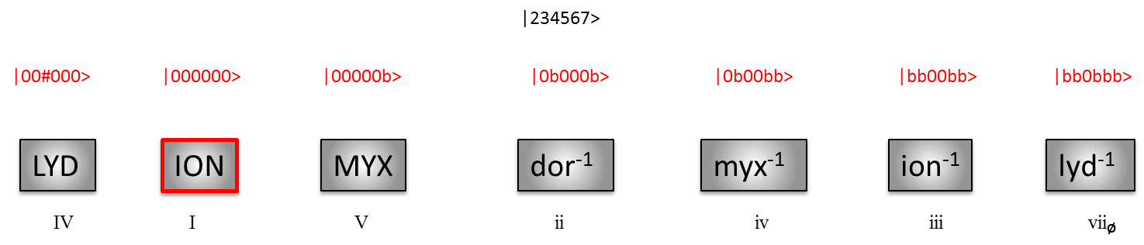
Figure 5: The major scale in the ionian basis.
Figure 5 shows the modal basis concept applied to the major scale in the traditional ionian basis, where ionian is the natural mode |♮> and also the absolute mode |0>. Considering this mode as our basis, we now measure all other modal positions relative to it. If we do this, we see that by conventional music theory, the myxolydian mode is one P5 jump up while the lydian mode is one P4 jump up (or a P5 jump down). But at the same time, |myx> is a |b7| away from |ion>, which itself is a |#4| away from lydian. We also see that in this basis the mode with the most accidentals will be locrian (lyd⁻¹) with five flats while the only sharp is in the lydian mode. Not much else can be revealed about A-space in this basis.
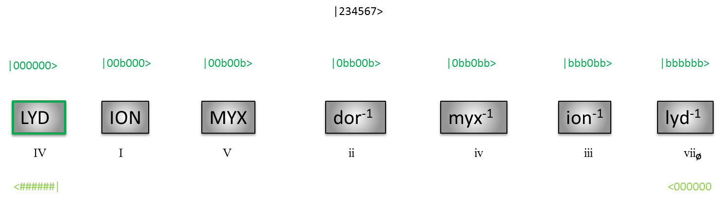
Figure 6: The major scale in the lydian, |♮> = |lyd>, and locrian, |♮> = |loc>, basis.
We now switch our starting point to the lydian mode and explore the lydian basis as shown in figure 6. In this basis, since lydian is the new natural mode, |♮> = |lyd>, we measure all modes relative to it. Ionian is no longer the natural mode but is now annotated as |b4>, though it remains the absolute mode. This is because in order to get to the Ionian mode from the lydian mode requires that you flat the fourth degree that, by definition of the lydian mode, you had already sharpened relative to the ionian mode. If this argument sounds circular, that’s because it is; there are as many basis as there are modes in the scale, each one internally consistent and respecting the underlying geometry but whose results are completely meaningless in another basis. Practically this means that the operation |b4| or the vector |b4> as a reference for the ionian mode in the lydian basis is valid only in the lydian basis. If we were to return to the traditional ionian basis, then performing a |b4| on any mode would not return you to the ionian basis, lydian basis, or any other bases in the major scale. The ionian mode’s role as the absolute mode means that it will remain the only reliable fixed point upon which we can measure any displacement, regardless of the natural mode chosen, hence the absolute moniker. As we examine the major scale in different bases, we start to see the underlying geometry of A-space. By placing the natural mode in the lydian basis we immediately see the pattern of growing flats. Starting at ionian with one flat and ending in locrian with six, we see that the major scale fills the space of one tritone. This can be seen in seventh row of table 2 or simply by noting that the locrian’s six flats in the lydian basis implies a modal length of a tritone relative to the natural mode (lydian) as per the rules set above.
If we now shift our perspective and place the origin on the locrian mode, we see the inverse nature of the underlying geometry. Now instead of the largest mode in this representation being six flats, here we have the largest representation being six sharps. We can attribute this as a natural consequence of group theory. Since the set of intervals constitutes a group, each element of the group must have an inverse. In music this translates to the P4 as the inverse of the P5, the seventh as the inverse of the second, the sixth as the inverse of the third, and P1 as the inverse of P8. It is therefore natural to expect that if as we are traveling by intervals in A-space, if it took an interval of a P5 to move in one direction then we should expect the reverse direction to encompass its inverse, a P4. In the case of A-space, this concept is realized by having a mode that allows you to move six flats in one direction encompassing six P5 jumps; but if you used this six-flat mode as your new starting point, you can move six sharps in the other direction encompassing six P4 jumps.
If we disallow the idea of a double accidental operator and a corresponding double accidental space, then we see that six flats or six sharps is as large as A-space can be. Furthermore, considering that the lydian basis allowed a vector with all flats a TT away and the locrian basis allowed a vector with all sharps also a TT away, it could be that the full-size of A-space is twice the tritone (P8). Or, instead of a single accidental space, we may need to consider two separate spaces, one for the flats and one for the sharps. Or that we may be traveling back and forth through a Euclidian space a tritone in size and just relabeling it as sharps or flats. We already know that our space in non-Euclidean (Euclidean space is metric; A-space is not) so we will now examine the dorian basis to help us resolve whether our space is singular or binary, connected or disconnected.
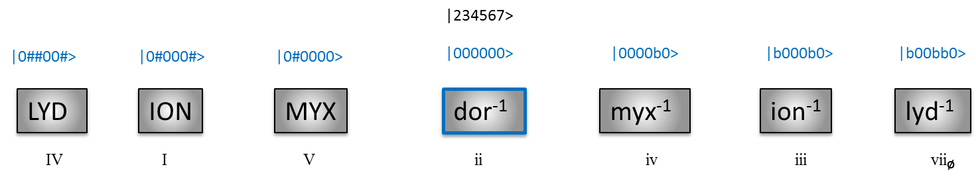
Figure 7: The major scale in the dorian basis, |♮> = |dor⁻¹>.
We now place our origin at the dorian mode, |♮> = |dor⁻¹>. We see that by placing the origin on the one mode that is palindromic, we establish a clear symmetry between the remaining forward modes and inverse modes, as well as in the pattern of sharps and flats. In fact, we see that the dorian mode is not only at the center of the circle of fifths major scale, it is also at the center of A-space. We can see that dorian nearest neighbors are both only one accidental distant, a sharp on one side and a flat on the other; thus it only takes one operation, sharp or flat, to establish the next link in the chain. Their next set of neighbors has two accidentals and two operations and their last set of neighbors three accidentals and three operations. We see that the dorian mode is right in the middle of accidental space and still spans a distance of TT since nothing has changed in the relationship between the lydian and locrian modes.
Returning to the question of the full-size of accidental space, examination of the locrian and lydian bases allowed us to deduce that A-space could be the size of an octave, two tritone sized disconnected spaces, or a singular tritonic space. By virtue of the geometry unveiled by the dorian basis, we see that the flats and sharps are connected and thus, A-space consists of a flat tritone in one direction and a sharp tritone in the other, with palindromic modes in the center. As confirmation of its full-size, consider that the largest factors in the Dorian basis only have three accidentals; therefore, there is still room for three more on either end. This confirms that the full span of A-space is a full octave, with half of it sharp and half of it flat, or P8 = TT(b) + TT(#). Moving the origin to the remaining modes (myxolydian, aeolian, and phrygian) reveals no new information on the topology of A-space. In each of these cases, the accidental representation of the modes will be some non-symmetric combination of sharps and flats reminiscent of the ionian mode and thus be redundant.
In figure 8 we summarize the results of our investigation above and add an important convention to our diagram: the P5 jumps are now color- and arrow-coded by the accidental operator that would cause them. This labeling is best understood in the lydian basis where going from lydian to ionian means taking a single P5 jump but also single |b4| operation. Then to go from the ionian to the myxolydian mode, one must take another jump by performing a |b7| operation in A-space. One more jump adds a |b3| to the mix and we arrive at dorian. Operators are cumulative as one travels from mode to mode in this diagram. Therefore, if we wished to calculate what operations would take us from the lydian mode to the myxolydian mode, then we would apply the |b4| and then |b7| operation to whichever basis representation we choose. We can see that the accidental spelling of each mode is uniquely created by traveling across this network. Notice that the modal length between locrian and lydian, a TT, is unique in so far as it is palindromic in its own right; traveling from locrian to lydian is exactly the same interval as traveling from lydian to locrian. Modes connected by flat operators in accidental space are known as accidental networks. In this paper we will interpret these networks as representing different accessible modes (nodes) using accidental operators (vertices) within A-space, with other interpretations to be discussed in future investigations. Let us next build the accidental network of the melodic minor.
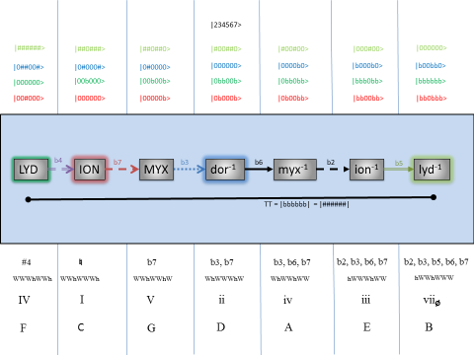
Figure 8: The major modes in A-space, the major network.

The melodic minor A-net
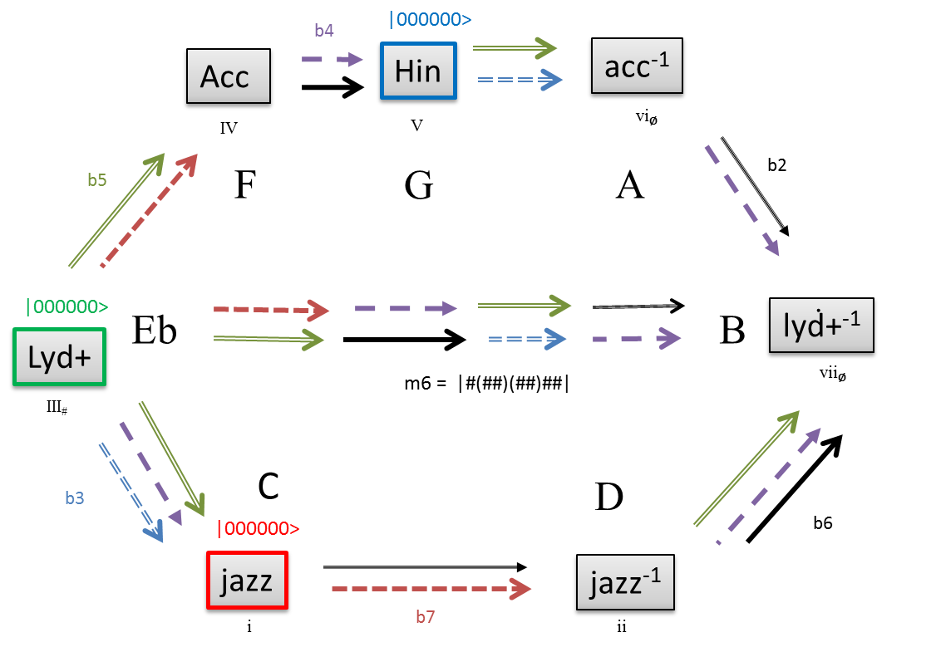
Figure 9: The jazz modes in A-space.
Having examined the major scale and gained familiarity with measurements within accidental space, we now consider other scales. The next scale of importance is the melodic minor or jazz scale. The jazz mode is the new assigned natural mode and only a |b3| away from the absolute mode. However as we can see in figure 7, this small change leads to a drastic changes in its network. We have again color-coded three modes to account for bases choices similar to the ones made in the major scale. For example, we have an inverse symmetry about the hindu axis just like we did around the dorian axis and the extent our network is determined by the modal length between lydian augmented and its inverse just like the extent of the major scale was determined by the modal length between lydian and its inverse.
Despite the intervallic symmetries, obvious points of symmetry breaking stand out. In the major scale, every non-palindromic minor mode had a corresponding major mode such that if you exchanged a mode for its inverse, you would flip the chord quality from minor to major or vice versa. In the jazz scale however, rotating about the hindu axis (i.e., switching every mode with its inverse), we observe that the first and second jazz modes have the correct inverse intervallic relationship but they are both minor; in other words, their qualities did not flip. In fact, the jazz mode is actually a minor–major mode so we can interpret the symmetry breaking as a result of the jazz inverse mode changing under inversion from minor to minor–major which is a weaker change than minor to full major or even minor to dominant. So while rotating about the dorian produced a perfectly anti-symmetrical configuration in the major scale, the same procedure around the hindu axis in the jazz scale produces a mode configuration that is almost equally anti-symmetric, but is not. Another point of symmetry breaking revolves around the lydian augmented axis. Whereupon in the major mode we had no structure such that we could rotate around the lydian axis, we see that the two paths in the jazz scale establish, at least visually, the notion of a rotation about the lydian augmented mode and its inverse.
Furthermore, whereupon the interval between lydian and its inverse was a tritone, within the jazz scale this same relative distance between lydian augmented and its inverse is a minor six or eight P5 jumps. This is a whole step larger than the similar interval in the major scale. It is also a large enough interval that cannot be represented with the single accidental A-space so far discussed. In order to discuss a transition generated by eight jumps, we would need two more scale degrees or allow double accidentals. Thus while these modes are perfectly well-placed within A-space (as can be seen from the Dorian basis), the accidental algebra as presented in this paper is not designed for a singular transition of that size… though of course both modes can always be reached through a succession of smaller jumps.
We can also see that the clean circle of a circle of fifths progression seen in the major scale has morphed into two distinct paths; each starting and ending the same modes, lydian augmented and its inverse respectively, with one path containing three modes and the other containing two. It is almost as if the jazz scale is created by grabbing the lydian and lydian inverse modes, stretching them out by a whole step, and allowing the remaining five modes to displace and relax relative to each other as in figure 9. This is an interesting dynamical interpretation but it is too early to tell if this is merely a mnemonic consideration or if it actually points toward some underlying dynamic of A-space
Our final observation is that it is impossible to construct a accidental network for the jazz scale with only singular jumps; the smallest movement within the entire network is two jumps, with some modes requiring three. The jazz scale is clearly more complex than the major scale in terms of its expression in accidental space and yet it still manages to preserves several of its inherent symmetries. This complexity however is offset by observing that a whole step can be traversed in one hop encompassing two jumps in the jazz network while that same whole step requires two hops in the major network. As will be immediately seen, the complexity of the jazz scale is complementary to the simplicity of the major scale as both are part of a larger whole.

The major plus melodic minor A-net: the modal wheel
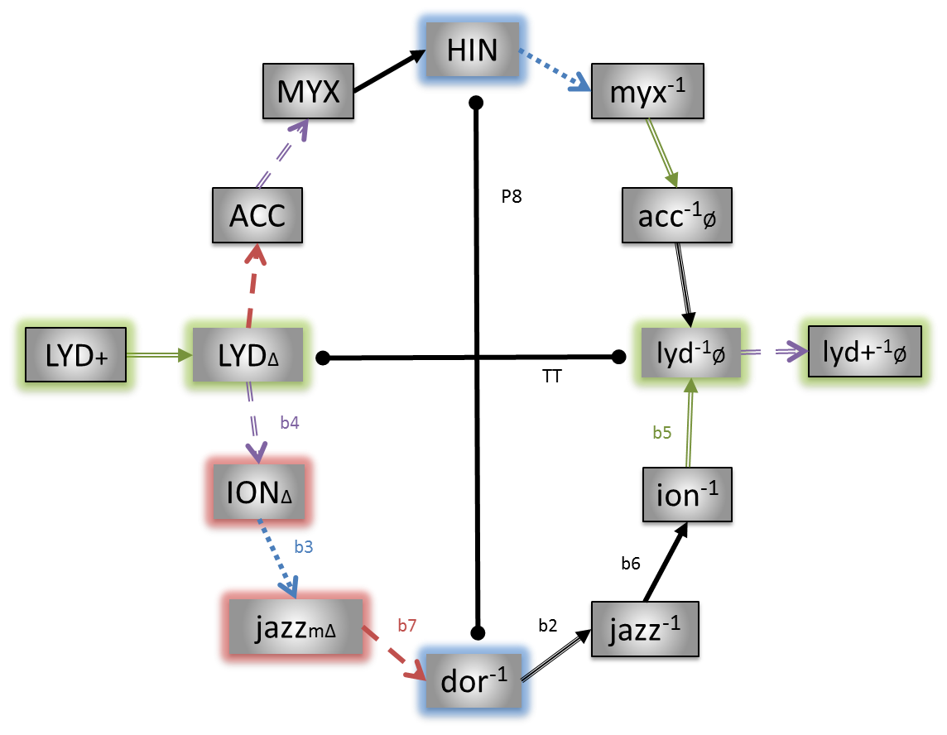
Figure 10: Major and jazz modes in A-space: the modal wheel.
While the jazz network consisted entirely of two or three simultaneous jumps, when we combine it with the major network we arrive at a network with only singular jumps, as is shown in figure 10. The modal wheel will refer to the major and melodic minor scales’ accidental network with only singular flat jumps. The network obeys the same accidental algebra established before and we have outlined the bases used in the previous analysis. We notice that as they do individually within their own scales, the palindromic dorian and hindu modes form a rotation axis about which the intervallic spellings of the modes are exact inverses of each other. We also note that in terms of chord quality, every major quality has an inverse in the minor quality, with the exception of the minor-major jazz mode. We can also immediately calculate that the dorian mode is P8 distant from the hindu mode by counting arrows. Viewed another way, the two palindromic modes about which the scales are inversely symmetric are “connected” to each other through an interval that is itself palindromic and won’t change under inversion. This is similar to the axis between lydian and it’s inverse that is also connected by a palindromic interval, the TT, and about which the total number of operators and modes are the same but rearranged. When we take these measurements into account, we see that the modal wheel is actually an ellipse with a major axis of P8 and a minor axis of TT.
One of the most important observations about the modal wheel is the uniqueness of its construction; there is no other way to construct it with singular jumps. There are many alternative ways to inter-connect the modes with two, three, or more simultaneous jumps, but the modal wheel remains unique in requiring only singular jumps. In the language of graph theory, this is means that the major network and the modal wheel are the only two simply connected graphs in A-space. To examine further what the modal wheel means in relation to other modes, let us add another scale into accidental space and see how that affects our network.

The modal wheel plus neapolitan major: the diatonic wheel
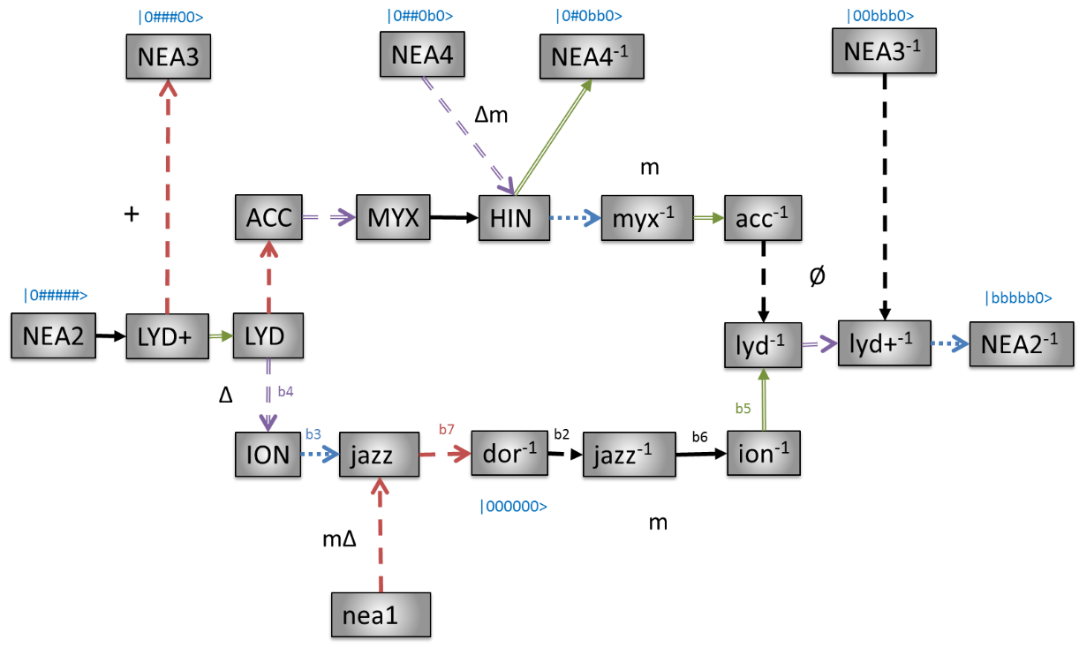
Figure 11: Major, jazz, and neapolitan major modes in A-space: the diatonic wheel.
Here we see the mapping of the neapolitan major modes relative to the modal wheel. The inclusion of the neapolitan major mode exhausts the possibilities for heptatonic scales with only whole and half-step spelling giving rise to it’s name, the diatonic wheel. One can deduct from the diagram that the neapolitan major accidental network alone would have some modal transitions requiring five simultaneous jumps. However, when attached to the modal wheel we see that each neapolitan major mode is only one jump removed from the modal wheel and if we minimize the number of jumps (not distance) relative to the absolute mode, each placement is unique. This defines the relationship of the modal wheel relative to every other mode and thus every other scale: it is the most stable modal configuration in A-space and every other scale “hangs” off of it. As an example, the diatonic wheel presents no alternatives in how to place the neapolitan modes based on the rule of minimal singular jumps; but for this to happen requires that the modal wheel already be present.
Visually examining the diagram, we can provide a quick analysis of the neapolitan scale as expanding into the far reaches of A-space where it adds a lot of major tonalities, but only one minor one. We notice that while the neapolitan major fourth mode is not at a position of minimal absolute length (that would require a |b6| off of |acc>), the choice of adding two more jumps and place it where it is brings out the explicit symmetry that exist within all of the major modes. This is a different symmetry than before for even though rotation about the <dor|hin> axis would still exchange their intervallic spellings, the chord qualities do not change at all. As well, the palindromic mode in this scale, the first mode, is a minor with no corresponding mode on the other side of the rotation axis. Therefore it explicitly breaks any symmetry present and we see that the neapolitan major modes show a high level of symmetry but a low level of variety. And this symmetry can only be expressed through the modal wheel; on its own, a neapolitan major network would be messy and unworkable.
Our final observation is that despite the single jumps at the extremes of the diatonic wheel, the neapolitan major modes still stay within the P8 confines of A-space. As in our previous discussion of <lyd+|lyd+⁻¹>, even though <nea2|nea2⁻¹> cannot be spanned with a single operator within A-space as defined in this paper the furthest modes defined so far (as measured from the dorian basis) are the second mode to the neapolitan major scale and its inverse, each with five accidentals and thus one accidental away from the border of six flats or six sharps.

The modal wheel plus harmonic minor: the harmonic wheel
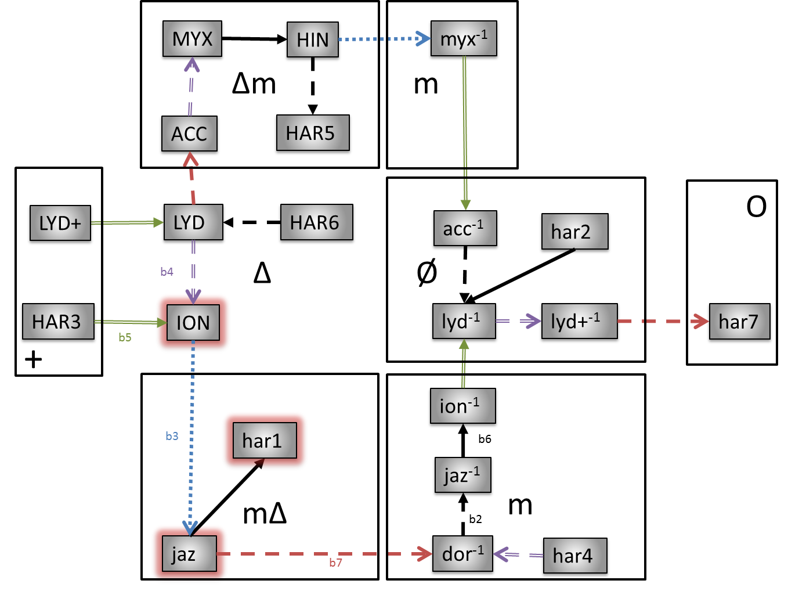
Figure 12: Major, jazz, and harmonic minor modes in A-space: the harmonic wheel.
If we substitute the harmonic minor for the neapolitan major in the diatonic wheel (alternatively, add it to the modal wheel), we immediately see that it has neatly added one mode to every chord quality, including a creating a new one in the fully diminished harmonic minor seventh. The inclusion of the harmonic minor modes in figure 12 require us to make placement choices based on chord quality groupings. Though |har4> could also be a |b3| off of |acc> and have the same absolute length (jumps from |0>) as where it is now, the choice is made to place it off |dor> due to its minor quality. Likewise, |har2> would have less jumps coming off |jaz⁻¹> with a |b5|, but due to it’s half diminished nature, we place it off |lyd> (thus adding two jumps that cancel out so the distance remains the same) to better showcase the chordal quality of that mode and enhances the quality clustering. These ambiguities may or may not be related to the fact that since the harmonic minor scale has a single minor third in its intervallic spelling, no inverse modes can be defined. In fact, since a) the diatonic wheel exhausted the possibilities for seven notes scales written entirely in whole or half steps and b) the inclusion of a minor third is the only other interval that allows for seven note constructions, then c) the scales of the diatonic wheel are the only ones that admit an inverse representation.
The addition of the harmonic minor modes therefore reinforces the chord qualities that had already been established in the modal wheel. This is in contrast to the neapolitan major modes that provided almost no variety and, as exemplified by the |nea2⁻¹> and |nea3⁻¹> modes, had unpredictable quality when got to sleep structure. Thus it may be an obvious statement that the harmonic minor enjoys more popularity than the neapolitan major because of the variety of chord qualities it offers. Yet here we see that maybe it’s not only the variety of chord qualities but also the structural properties of the diatonic wheel that make it more popular than the diatonic wheel, her fraternal twin brother so to speak.

The almost full A-net: the big wheel.
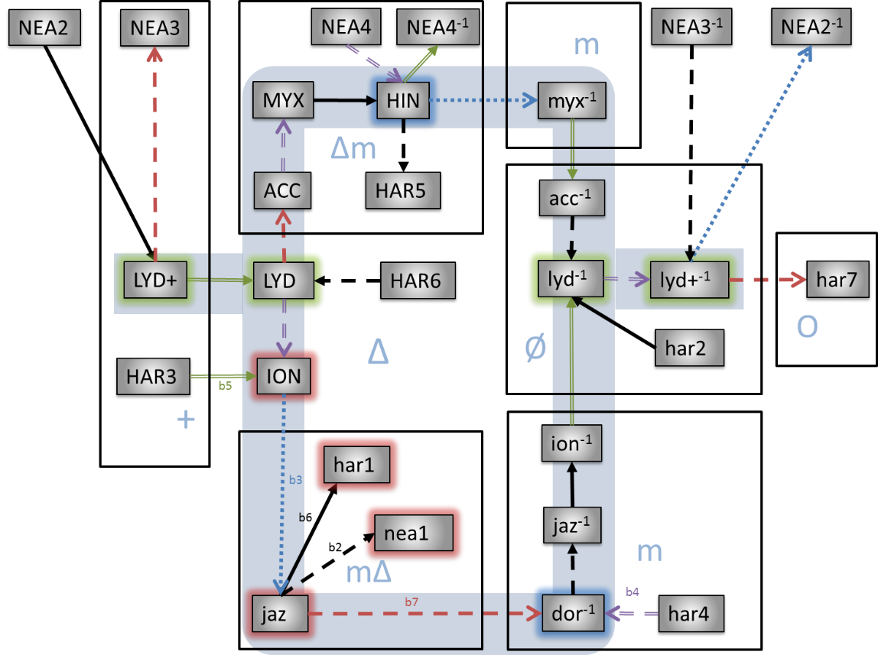
Figure 13: Four heptatonic scales in A-space: the full accidental network.
We are finally in a position to integrate the four scales that are the scope of this paper. We have kept the bases color coding as well as added a blue background the modal wheel to set it apart. Let us review some of the rules and conventions that go into the creation of a accidental network. For starters, as is obvious from figure 13 and our previous definitions, we restrict ourselves to movements of a single jump. While there are multiple ways to reach a mode through multiple simultaneous jumps, and certain networks won’t allow less than one jump, the complete accidental network (so far) can be defined as having each mode be accessible to at least one other mode in the network by a single jump; i.e., by keeping the graph simple. In effect, we see Pythagoras’s dream of creating a musical system with only intervals of a fifth realized. When looking for where to put a mode in relation to another and calculating it’s minimal path, we default to the absolute mode, |0> = |ion>, as our starting point. Since the majority of instruments are tuned in such a way that the ionian mode represents no accidentals, |ion> represents the only true zero vector in the system. The four-scale accidental network as presented in figure 13 adheres to the rule of minimal singular jumps but is still incomplete. And while more scales will be added to the network, the neapolitan major and harmonic minor are the only two that independently attach themselves to the modal wheel; the remaining four scales mentioned in footnote 1 all require the structure figure 13 to be in place before being successfully integrated while keeping the graph simple. This completed full accidental network, consisting of at least eight scales and fifty-six modes, will be presented in future investigations although the readers could create it for themselves following the procedures set forth in this paper.
Another thing to notice is that this clustering of chord qualities, for the first time as far as the author knows, visually shows a metric relationship amongst all qualities, i.e. one with a non-arbitrarily defined concept of near or far. This helps us understand, for example, why there is a solitary minor mode in the upper right-hand corner. Despite the clean grouping of all the qualities, this minor mode seems out of place. But if one were to consider each quality cluster as a singular entity (for example consider only the boxes surrounding the chord qualities), then one can see that to go from the major quality to the minor–major quality involves a |b3| and to go from major to dominant takes a |b7|. Now, to go from the minor–major mode to the minor modes takes a flat seven and thus to maintain the symmetry on the other side, the step out of the dominant mode must include a singular |b3| otherwise it would take two jumps to reach the acoustic inverse (the altered mode) which would break the modal wheel. Hence having the |myx⁻¹> = |aeo> there is essential in order to keep the modal wheel stable and to maintain a steady flow from dominant to (eventually) half-diminished.
We leave it up to the reader to find other useful and interesting insights derived from exploring accidental networks. In traveling through any network, remember that in traversing a path between two modes, if two arrows of the same degree point in opposite directions, then the cancel out. So for example, in going from ionian to myxolydian, we note that we first have to |#4|, then |b7|, and then |b4|. As has been discussed throughout the paper, flat and sharp operations on the same scale degree cancel and thus all that remains is |b7|, which is the correct operation to reach the myxolydian mode from the ionian mode or alternatively and the correct interval length of one P5 jump to travel from C from G. These simple visual rules allow for efficient manipulation and navigation of the accidental network and make traveling between different modes not only aesthetically appealing but also mathematically precise.

Future investigations
The purpose of this paper was to introduce the fundamental concepts of accidental algebra, accidental space, the modal wheel, and accidental networks. The algebra and networks discussed previously are logically and mathematically consistent and provide for a novel way of navigating through the modes and understanding chord qualities. While it is not the purpose of this paper to comment or debate on the utility of this model, it is the opinion of the author that its consistency and aesthetic appeal merit further investigation.
Part two, tentatively subtitled “accidental algebra” will more rigorously develop and explore the algebraic aspects of accidental space. We will see how treating the modes as vectors we can identify their inner product as a modal length and how the flat and sharp operators can be cast as a form of spinors in Hilbert space thus giving us access to that rich terminology and mathematical machinery to understand accidental space.
Part three, tentatively subtitled “full network analysis”, discuss the implications of putting (currently) over 60 modes can be networked together and fit consistently within A-space as shown in figure 14. We will discuss the implications of all these modes together including the notion of quality clusters, usefulness of particular scales, how modal wheels can be used in analysis and compostion and more. We will also compare this model with traditional music theory as well as other established modal models such as those of Russel [REF] and Miller [REF].
Part four, tentatively titled “alternative interpretations” will view modes as energy states where the inner product is interpreted as measuring a transition probabilities and generating a vacuum expectation values. Since this interpretation is also used to describe electrons orbiting an atom and because the shape of the modal wheel is reminiscent of a Feynman diagram, an analogy with atomic structures will be made that is useful even if only for mnemonic or pedagogic purposes. The last interpretation is to treat accidental networks as true networks and analyze them in terms of its nodes and vertices. Merely by inspection we can already tell that, in the language of network theory, accidental networks are complete, connected, sometimes simple, directed graphs; the jazz network is complementary to the major network; that the chord qualities set up clusters, that the |b3|, |b5|, and |b7| operations are articulation nodes between quality clusters; that the ego network of some nodes may be empty; and more. Finally, I will introduce a new visualization of accidental space called the major mode cube in which the modes and operators are treated as complex valued and thus each mode represents a point in our 6-dimensional complex quasi-pseudometric space.
In part five, tentatively subtitled “corpora analysis and interpretation”, I will apply results from parts one and two to analyze various bodies of musical work. Of particular interest will be analyzing the works of jazz musicians in terms of their usage of the jazz scale as well as the works of classical musicians in terms of their usage of the neapolitan major and harmonic minor scales. I will also use the rock-and-roll catalogs of the past 60 years as well as Hindustani music as other bodies of work. Using A-space as a common framework will expose similarities and differences in these styles and perhaps even suggest new ones. Of particular interest is in comparing the atonal Eastern music styles with the total Western music styles.
Another avenue of investigation lay in the structure of the modal wheel. The uniqueness of its construction and the aesthetic beauty of it symmetry can be examined from several perspectives. For example, several times in the paper I made use of group theory terminology and concepts. Therefore, a group theoretical treatment of the modal wheel is in order. We can already consider the accidental network in group theory terms to be a single generator (<P5>) non-cyclic Cayley graph. Further connections with set, group, and network theory would better help categorize and understand A-space and ultimately music such that exploring the Banach-Tarski paradox, for example, may be a means of understanding how music is essentially orijikan, making shapes by folding time.

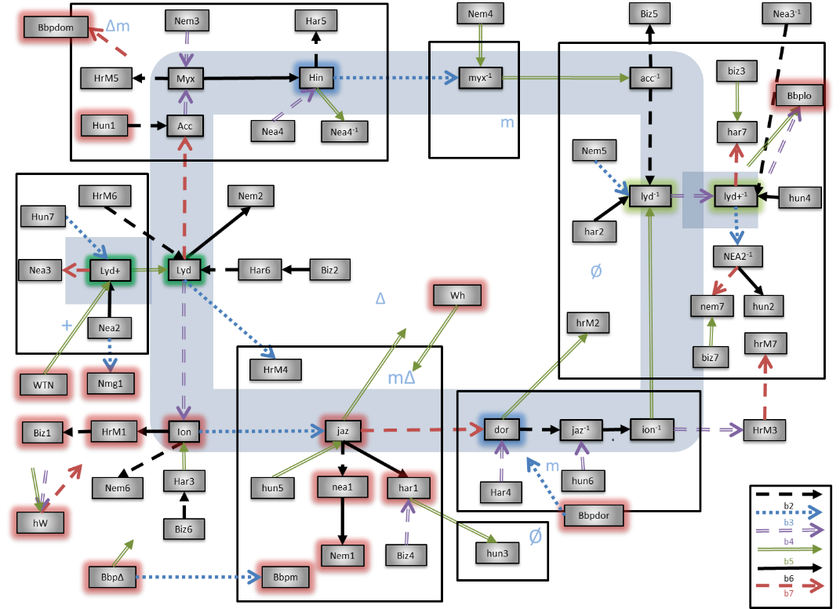
Figure 14: 57 connected and 7 semi-connected modes in A-space.

References
Carter, N. (2009). Visual Group Theory. The Mathematical Association of America.
List_of_musical_scales_and_mode. (2015, August 27). Retrieved from Wikipedia: https://en.wikipedia.org/wiki/List_of_musical_scales_and_mode
Shankar, R. (1988). Principles of quantum mechanics. New York: Plenum press.

Four other heptatonic scales, the harmonic major, neapolitan minor, double harmonic, and hungarian (Modes and scales, 2015), are also consistent with the results in this paper but will not be discussed.
The full accidental vector is actually |123456> with the first scale degree referring to one of 12 values outside (?) of A-space, tentatively key space. However, as long as we stay within one key, the first scale degree is unimportant and the vector |23456> suffices.
Key changes will be discussed in part two where our extended algebra allows us to discuss concepts such as |Gion> = |Clyd> or |Fion> = |Cmyx>.
In our diagrams, we will adopt the convention of replacing the natural sign with a zero. This is for sharper contrast between the flat and sharp operators.
Though sometimes it may be necessary to annotate double accidentals (e.g., in the absolute spelling of the seventh mode of harmonic minor, |bbbbb(bb)>), this is an illusion insomuch as a basis (dorian) can always be chosen such that this and all other heptatonic modes remain within the single accidental A-space.
The accidental operators also interchange two adjacent elements in a modes intervallic spelling. Seeing the intervallic spelling changes after each singular flat or sharp accidental operations will help establish the pattern.
|nea2> and |nea4> both violate the condition of minimal absolute path by their placement in figure 13. However, having established that even these two modes have an unambiguous minimal path, we move them so as to enhance the readability of the diagram and chord quality clustering.
This makes |b3|, |b7|, and eventually |b5| articulation nodes in the language of graph theory since cutting those links would create independent quality clusters. Musically, the accidental nature of these scale degrees exactly defines what a chord is (the root, third, fifth, seventh scale degrees) and by virtue of whether it's flat or not, what quality it has.

